Centre of mass

In the chapter 7.1.1 “Calculating the centre of mass” the altitude in which single gas measurements of a cycle can be placed. This is called centre of mass, regarding this experiment, and is equivalent with the centre of mass of the air sample collected during one cycle.

In the abovementioned chapter the following formula has been derived:

$$h_{cm}=\frac{\int_{t_{1}}^{t_{2}}{\left(h\left(t\right)-h_{0}\right) Π\left(t\right) dt}}{\int_{t_{1}}^{t_{2}}{Π\left(t\right) dt}}+h_{0}$$

where h0 is the experiment’s altitude at the start of a new cycle and h(t) is the experiment’s altitude at the moment t. From the chapter “Environmental and Experiment’s conditions” it is clear that the ascending phase was linear with a mean value of υ = 4.7 m/sec, thus:

$$h\left(t\right)=υ*t$$

Furthermore, from the chapter “Pump modeling” the flow-rate function Π(t) has been expressed as:

$$Π\left(t\right)=d*c^{t}$$

where d is a constant depending on the cycle number, and c =0.95335. With that being said, the center of mass can be expressed as:

$$h_{cm}=υ\frac{\int_{0}^{T}{t c^{t} dt}}{\int_{0}^{T}{c^{t} dt}}+h_{0}$$

where T is the duration of the corresponding cycle. By solving the integrals, hcm is calculated:

$$h_{cm}=υ\frac{T c^{T}-\frac{c^{T}-1}{\ln{c}}}{c^{T}-1}+h_{0}$$

The above result is very important because it is independent of the corresponding cycle’s number.

By implementing this formula to the real altitude data for each cycle during the ascending phase, the following graph is generated. This graph demonstrates the point of measurement that is equivalent to the center of mass of the sample gathered during one cycle. Every gas measurement that will be presented will refer to the altitude of the center of mass of the corresponding cycle. The negative and positive error bars show the starting and the ending point of each pressurization stage, correspondingly.

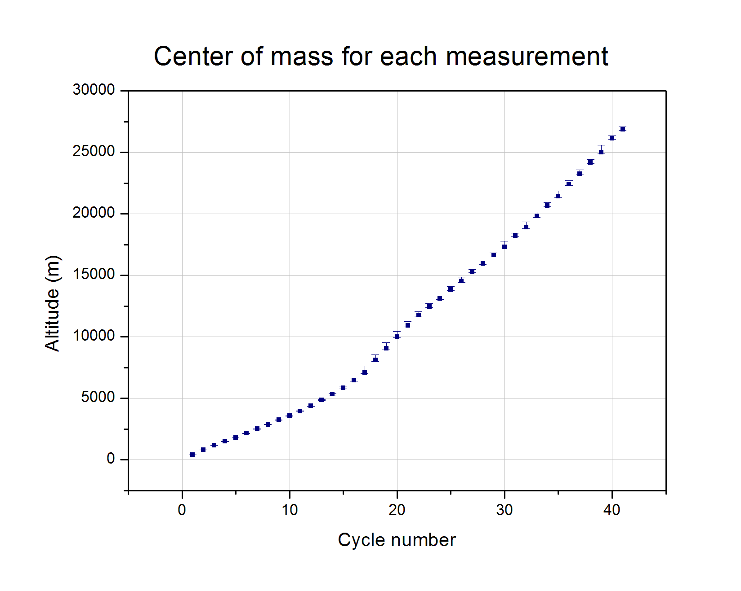

Graph 1: Altitude measurements of each cycle

In order to clarify the use of the center of mass formula, the following graph is presented, which is generated by the altitude residuals to focus on the error bars’ scale.

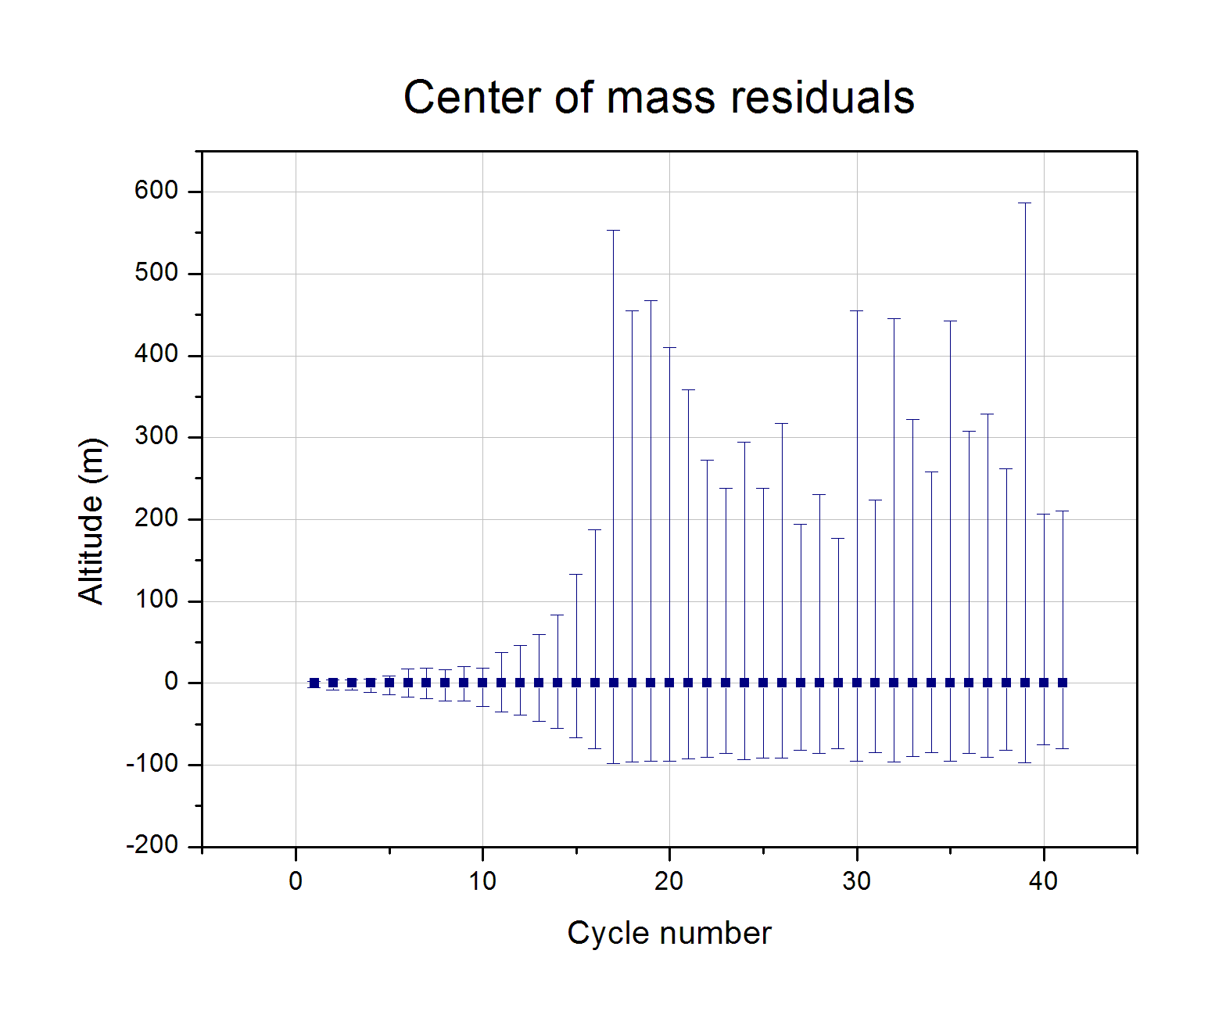

Graph : Error bars scale

From this graph it is being clear that estimating the center of mass is important, since there are cycles that lasted about three minutes, during which time the experiment’s altitude has changed significantly. The error margins range from some meters to almost 700 m. If symmetric error bars had been assumed, it would mean that the pump’s flow-rate was constant, which is completely wrong. The center of mass is shifted to lower values than the mean altitude of each pressurization stage, which is consistent with the observational data.